**JAVASCRIPT PROJECT**

**Create a module that exports a function and import it into another file.**

**OUTPUT**

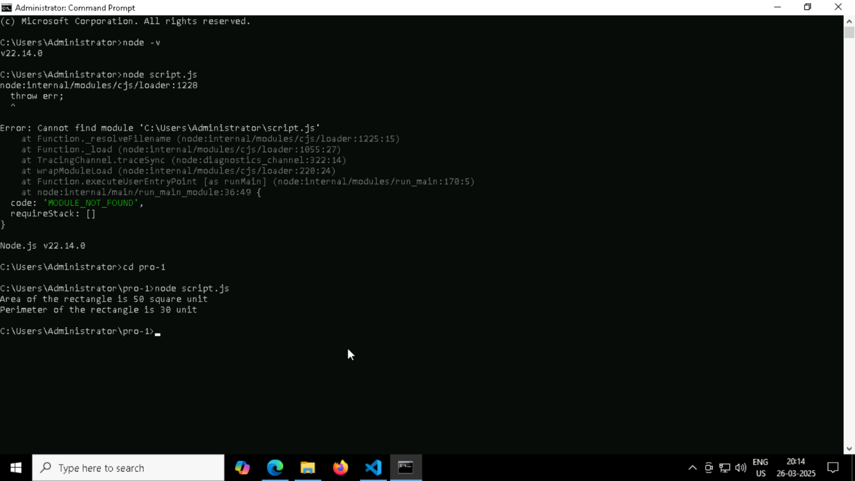

**Convert a JavaScript object to JSON and back using JSON.stringify() and JSON.parse().**

**OUTPUT**

**Using require() Method (CommonJS)**

**OUTPUT**

**Define a class Animal with properties and a method, and create instances**

**Write a promise that resolves after a delay and convert it into an async function using async/await.**

